**KABARAK UNIVERSITY**



**SCHOOL OF BUSINESS AND ECONOMICS**

**BBIT 414: IT PROJECT 1**

**WAREHOUSE SPACE MANAGEMENT SYSTEM**

**DONE BY:**

**ALVIN MORRIS MBURU: BBIT/MG/1111/09/21**

**AN IT PROJECT SUBMITTED TO THE DEPARTMENT OF COMPUTER SCIENCE AND INFORMATION TECHNOLOGY (UNDER THE SCHOOL OF SCIENCE, ENGINEERING AND TECHNOLOGY) IN PARTIAL FULFILMENT OF DEGREE IN BACHELOR OF BUSINESS INFORMATION TECHNOLOGY.**

**MAY-AUGUST, 2024**

# DECLARATION

I affirm that this is my original work and to the best of my understanding no one has done the same project before in this institution or any other university in Kenya.

STUDENT:

ALVIN MORRIS MBURU

Sign………………. Date………………………..

LECTURER:

Mr. RUORO SIMON

Sign………………. Date………………………..

# ACKNOWLEDGEMENT

I begin with heartfelt gratitude, acknowledging the boundless blessings bestowed upon me by the divine grace of God. My journey through this research endeavor has been illuminated by His unwavering presence and guidance.

My sincere appreciations extend to Mr. SIMON RUORO, whose unwavering support and insightful direction from the School of Science, Engineering, and Technology at Kabarak University has been instrumental in my success. His leadership has ignited in me a profound sense of purpose and determination, shaping my research methodology and refining my presentation with clarity and precision. Working under his tutelage has been both a privilege and an honor, for which I am deeply thankful.

I also extend my gratitude to my parents whose unconditional love and unwavering support has been the cornerstone of my journey. Their acceptance and financial assistance has not only eased my path but have also served as a source of encouragement and inspiration.

**ABSTRACT**

Efficient warehouse space management is crucial for optimizing logistics operations, particularly with the rise of e-commerce and global supply chains. Warehouses face increasing pressure to maximize storage capacity while ensuring quick and accurate order fulfilment. Ineffective space management leads to wasted space, increased operational costs, and reduced productivity, ultimately impacting the bottom line. Despite advancements in technology and warehouse management systems, many warehouses still struggle with under-utilized or poorly organized space. This problem is exacerbated by fluctuating inventory levels, diverse product sizes, and dynamic demand patterns. As a result, companies experience higher handling times, increased labour costs, and suboptimal use of storage areas. Addressing the inefficiencies in warehouse space management can lead to significant cost savings and productivity improvements. By optimizing space utilization, companies can reduce operational expenses, improve order accuracy and speed, and enhance overall supply chain efficiency. This study aims to provide actionable insights and methodologies for improving warehouse space management, thereby offering tangible benefits to businesses. The primary objectives of this study are to identify common challenges and inefficiencies in current warehouse space management practices, develop strategies and frameworks for optimizing space utilization, and evaluate the impact of these strategies on operational performance metrics such as storage capacity, order fulfilment time, and cost reduction. The study will employ a mixed-methods approach, combining qualitative and quantitative research methods. Initially, a comprehensive literature review will be conducted to identify existing theories and practices in warehouse space management. This will be followed by case studies and interviews with industry professionals to gather practical insights and real-world examples. Quantitative data analysis will be performed using warehouse management system data to identify patterns and correlations between space management practices and operational performance. Additionally, simulation modelling will be used to test and validate proposed optimization strategies in a controlled environment before recommending their implementation in actual warehouse operations. This study aims to provide a comprehensive guide to improving warehouse space management, ultimately enhancing the efficiency and competitiveness of logistics operations. By addressing these inefficiencies and developing robust strategies, businesses can achieve substantial improvements in their overall operational performance, resulting in a more streamlined and cost-effective supply chain.

Table of Contents

DECLARATION 2

ACKNOWLEDGEMENT 3

TABLE OF FIGURES 7

CHAPTER ONE 8

INTRODUCTION 8

1.2 BACKGROUND OF THE STUDY 8

1.3 STATEMENT OF THE PROBLEM 10

1.4 PURPOSE OF THE STUDY 10

1.5 MAIN OBJECTIVE 10

1.5.1 Specific Objectives 10

1.6 RESEARCH QUESTIONS 10

1.7 PROPOSED SYSTEM 11

1.8 SYSTEM MODULES 11

1.9 JUSTIFICATION OF THE STUDY 11

1.10 FEASIBILITY STUDY 11

1.11 SCOPE AND LIMITATION OF THE STUDY 12

1.11.1 Scope 12

1.11.2 Limitations 12

CHAPTER TWO 13

LITERATURE REVIEW 13

2.1 GENERAL OVERVIEW OF WAREHOUSE SPACE MANAGEMENT 13

2.2 METHODS OF IDENTIFYING FEATURE SELECTION TECHNIQUES 16

2.2.1 Expert Knowledge and Heuristics 16

2.2.2 Statistical Analysis 16

2.2.3 Machine Learning Algorithms 16

2.3 EVALUATION OF THE CORRELATION BETWEEN OPTIMAL FEATURES 16

2.3.1 Correlation Analysis 16

2.3.2 Multicollinearity Detection 16

2.3.3 Dimensionality Reduction 17

2.4 USER SECURITY AWARENESS LEVEL 17

2.4.1 Training Programs 17

2.4.2 Regular Audits and Assessments 17

2.4.3 Security Policies 17

2.5 PROTOTYPE DESIGN AND DESIGN FRAMEWORK 17

2.5.1 Requirements Analysis 17

2.5.2 User Interface (UI) Design 18

2.5.3 System Architecture 18

2.5.4 Prototype Development 18

2.5.5 Testing and Feedback 18

2.6 DESIGN FRAMEWORK 18

2.6.1 Agile Methodology 18

2.6.2 Modular Design 18

2.6.3 User-Centred Design 19

2.6.4 Security by Design 19

CHAPTER THREE 20

RESEARCH, DESIGN, AND METHODOLOGY 20

3.1 RESEARCH DESIGN METHODS 20

3.2 LOCATION OF THE STUDY 20

3.3 POPULATION OF THE STUDY 20

3.4 SAMPLING PROCEDURE AND SAMPLE SIZE 20

3.5 DATA COLLECTION PROCEDURE 20

3.5.1 Surveys 20

3.5.2 Interviews 21

3.5.3 Observations 21

3.6 SYSTEM DEVELOPMENT METHODOLOGY 21

3.7 SYSTEM ANALYSIS AND DESIGN 21

3.7.1 Requirements Gathering 21

3.7.2 System Architecture Design 22

Functional and Non Functional Requirements 22

Functional Requirements 22

Architectural Design 26

3.7.3 Prototyping 27

3.7.4 Iterative Development 27

Conclusion 28

REFERENCES 29

APPENDICES 30

# TABLE OF FIGURES

Figure 1:Agile Methodology Diagram 21

Figure 2: Context Diagram 24

Figure 3: Usecase 24

Figure 4: Data Flow Diagram 25

Figure 5: Architectural Design diagram 26

Figure 6: ERD diagram 27

# CHAPTER ONE

# INTRODUCTION

In today's rapidly evolving logistics and supply chain landscape, efficient warehouse space management is crucial for operational success. The increasing demand for fast, reliable, and cost-effective storage solutions has highlighted the need for advanced tools to optimize warehouse space utilization. This chapter introduces a comprehensive study on the development of a Warehouse Space Management system, designed to enhance the utilization and management of warehouse space through innovative technology.

# 1.2 BACKGROUND OF THE STUDY

Warehouse space management is a critical aspect of logistics and supply chain operations, serving as the backbone for efficient inventory handling, storage, and distribution. Effective space management within a warehouse involves strategically organizing the physical space to maximize storage capacity, streamline operations, and reduce costs. This process encompasses several key components, including layout design, inventory categorization, and the utilization of advanced technologies such as warehouse management systems. Each of these elements plays a vital role in ensuring that a warehouse operates smoothly and meets the demands of modern business environments.

The layout design of a warehouse is the foundation of space management. A well-designed layout optimizes the flow of goods, minimizes the distance travelled by workers, and enhances overall efficiency. This involves careful planning of aisles, storage areas, and workstations. For instance, high-traffic zones should be placed near shipping and receiving docks to reduce handling time, while less frequently accessed items can be stored in more remote areas. Additionally, the layout must accommodate different types of storage solutions, such as pallet racking, shelving units, and mezzanines, each tailored to specific inventory needs. By thoughtfully designing the warehouse layout, businesses can significantly improve their operational efficiency and responsiveness to market demands (Gu, Goetschalckx, & McGinnis, 2010).

Inventory categorization is another crucial element of warehouse space management. Efficient categorization ensures that items are stored logically and retrieved quickly, which is essential for maintaining high levels of productivity. This process involves grouping similar items together, often based on factors such as size, weight, or turnover rate. For example, fast-moving goods should be placed in easily accessible locations, while slow-moving items can be stored further away. The adoption of inventory management techniques such as ABC analysis, which classifies items based on their importance and usage frequency, can further enhance the organization and accessibility of inventory. Proper categorization not only improves space utilization but also helps in minimizing errors and reducing the time required for order fulfilment.

The integration of advanced technologies, particularly warehouse management systems, has revolutionized warehouse space management. A warehouse management system provides real-time visibility into inventory levels, locations, and movements, enabling more precise control over storage and retrieval processes. These systems can automate many tasks, such as tracking inventory, managing orders, and optimizing storage locations based on real-time data. The use of warehouse management system also facilitates better decision-making through data analytics, helping managers identify inefficiencies and opportunities for improvement. Moreover, the implementation of automation technologies, such as automated guided vehicles and robotic picking systems, further enhances space utilization and operational efficiency by reducing the reliance on manual labour and increasing accuracy (Baker & Canessa, 2009).

Effective warehouse space management also involves continuous monitoring and improvement. As business needs and inventory volumes change, warehouses must adapt their strategies to maintain optimal performance. This may include reconfiguring layouts, adjusting storage solutions, or investing in new technologies. Regular audits and performance reviews can help identify areas for improvement and ensure that the warehouse operates at peak efficiency. Additionally, staff training and engagement are vital for successful space management, as knowledgeable employees can contribute to identifying inefficiencies and suggesting practical solutions.

In conclusion, warehouse space management is a multifaceted discipline that requires a strategic approach to layout design, inventory categorization, and the integration of advanced technologies. By optimizing these elements, businesses can enhance their operational efficiency, reduce costs, and improve customer satisfaction. As the demands on supply chains continue to evolve, effective warehouse space management will remain a critical factor in achieving competitive advantage and operational excellence.

# STATEMENT OF THE PROBLEM

Many warehouses today struggle with inefficient space utilization, leading to wasted resources and increased operational costs. The primary issues include: Poor space allocation strategies. Difficulty in tracking available space in real-time. Inadequate planning for incoming and outgoing shipments. These challenges result in decreased productivity, increased handling times, and higher costs, necessitating a robust solution (Gu, Goetschalckx, & McGinnis, 2010).

# 1.4 PURPOSE OF THE STUDY

The purpose of this study is to develop and evaluate a Warehouse Space Management system that addresses the current inefficiencies in space management within warehouse operations. The system aims to provide a comprehensive solution for real-time space management and optimization of storage processes.

# 1.5 MAIN OBJECTIVE

The main objective of this study is to design, develop, and implement a Warehouse Space Management system that improves the efficiency and effectiveness of warehouse operations by optimizing space utilization and enhancing real-time space management.

# 1.5.1 Specific Objectives

1. **To develop an intuitive user interface:** Design an intuitive and user-friendly interface that allows warehouse staff to easily navigate the system, access key information, and perform tasks related to space management with minimal training.
2. **To** design the system to be scalable and flexible, allowing it to adapt to varying warehouse sizes, inventory types, and operational demands as the business grows.
3. **To** establish mechanisms for continuous monitoring, feedback, and updates to ensure the system evolves with changing warehouse needs and technological advancements.
4. **To design a system than can be accessible in any mobile:** Develop a mobile version of the system to enable warehouse staff to access and manage space utilization on-the-go, enhancing flexibility and responsiveness in warehouse operations.

# 1.6 RESEARCH QUESTIONS

To achieve the objectives of this study, the following research questions will be addressed:

1. What are the key usability features that warehouse staff prioritize in an interface for space management tasks?
2. What architectural frameworks and technologies are best suited for developing scalable and flexible warehouse management systems?
3. What methods can be employed to continuously monitor the system’s performance and user satisfaction in a warehouse setting?
4. What are the key considerations for developing a mobile-friendly version of the warehouse management system?

# 1.7 PROPOSED SYSTEM

The proposed system is a Warehouse Space Management System that integrates advanced technologies to provide a user-friendly interface for warehouse managers. The system will include modules for space allocation, real-time monitoring, and analytics.

# 1.8 SYSTEM MODULES

1. Space Allocation Module: Optimizes the use of available warehouse space based on inventory size, type, and turnover rates (Baker & Canessa, 2009).
2. Real-Time Space Tracking Module: Uses barcode scanning and database management to provide real-time updates on available and occupied space.
3. Space Utilization Analytics Module: Analyses data to generate insights and reports for better decision-making and continuous improvement.

# 1.9 JUSTIFICATION OF THE STUDY

This study is justified by the need to improve warehouse efficiency, reduce operational costs, and enhance the overall supply chain performance. By addressing the inefficiencies in current space management practices, the proposed system can significantly contribute to the competitiveness and sustainability of logistics operations.

# 1.10 FEASIBILITY STUDY

A feasibility study was conducted to assess the practicality of developing the Warehouse Space Management system. The study evaluated technical, economic, and operational aspects:

Technical Feasibility: The availability of barcode scanning technology and database management systems ensures that the technical requirements for the system are met (Richards, 2017).

Economic Feasibility: The cost of developing and implementing the system is justified by the potential savings from improved space utilization and reduced labour costs (Frazelle, 2002).

Operational Feasibility: Warehouse staff and management are capable of adopting the new system with minimal training due to its user-friendly design.

# 1.11 SCOPE AND LIMITATION OF THE STUDY

# 1.11.1 Scope

The scope of this study includes:

Development of a functional prototype of the Warehouse Space Management system.

Testing and evaluation of the system in a real-world warehouse environment.

Analysis of the system's impact on warehouse space utilization and efficiency.

# 1.11.2 Limitations

The study has several limitations:

The prototype may not include all desired features due to time and budget constraints.

The evaluation will be limited to a single warehouse, which may affect the generalizability of the findings.

Potential resistance to change from warehouse staff could impact the implementation and adoption of the system.

# CHAPTER TWO

# LITERATURE REVIEW

# 2.1 GENERAL OVERVIEW OF WAREHOUSE SPACE MANAGEMENT

Warehouse space management is a pivotal element in logistics and supply chain management, significantly influencing operational efficiency, inventory control, and cost reduction. This review examines existing research and projects on warehouse space management systems, focusing on the technological advancements, methodologies, and outcomes that have shaped this field.

Warehouse space management entails the strategic allocation and utilization of space within a warehouse to maximize efficiency. Key components include inventory placement, space optimization, and the integration of technology for real-time tracking and management. Effective management of warehouse space can lead to considerable improvements in operational efficiency and cost savings.

Artificial Intelligence (AI) and Machine Learning (ML) are increasingly employed to predict demand, optimize inventory levels, and enhance space utilization. These technologies analyse historical data to forecast future inventory needs, allowing for proactive space management. Automation and robotics, including automated guided vehicles (AGVs) and robotic picking systems, contribute to efficient space utilization by reducing the need for wide aisles and enabling higher-density storage solutions.

Several case studies and projects illustrate the effective application of these technologies in warehouse space management. Amazon, for instance, has implemented a sophisticated space management system that uses AI, robotics, and real-time data analytics. Their Kiva robots optimize storage space by transporting shelves to human workers, reducing aisle space and improving picking efficiency. Similarly, Walmart uses a combination of IoT, WMS, and AI to dynamically adjust inventory placement based on real-time data, thus reducing stock outs and overstock situations. Prologis, a global logistics real estate provider, has developed the Prologis Labs initiative to test and implement new technologies for space optimization, including advanced sensors and AI.

Research studies further highlight innovative approaches to warehouse space management. For example, a study by Singh and Verma (2020) explores the use of genetic algorithms for warehouse space optimization. Their model, which considers various constraints such as storage capacity, product compatibility, and retrieval times, demonstrated significant improvements in space utilization and operational efficiency. Another project by Zhang et al. (2021) investigated the application of deep learning techniques to predict and manage warehouse space requirements. Their system uses historical data to forecast future storage needs, enabling proactive space planning and reducing wastage.

Despite these advancements, several challenges remain in warehouse space management. Integrating modern solutions with existing legacy systems can be complex and costly. The effectiveness of space management systems relies heavily on the accuracy of input data, and inaccurate data can lead to suboptimal decisions. Additionally, solutions must be scalable to accommodate the varying sizes and complexities of warehouses. Future research and development should focus on enhancing interoperability, improving data accuracy, and developing scalable solutions that can adapt to different warehouse environments.

Based on the existing research and projects outlined in this review, there are several gaps and challenges in warehouse space management that this system could potentially address:

Integration with Legacy Systems: Many warehouses still rely on legacy systems that may not easily integrate with modern technologies like AI and IoT. This system could focus on providing seamless integration solutions that minimize disruption and maximize compatibility with existing systems.

Data Accuracy and Decision Making: One of the critical challenges mentioned is the accuracy of input data. This system could implement robust data validation and cleaning processes to ensure that decisions regarding space allocation are based on accurate information. This could involve using advanced data analytics techniques to detect and correct anomalies in real-time.

Scalability and Adaptability: Warehouse environments vary widely in size, layout, and operational complexity. This system could offer scalable solutions that can be tailored to different warehouse sizes and configurations. This might involve modular design principles that allow for flexible deployment and customization based on specific warehouse needs.

Optimization under Constraints: Previous studies have explored optimization techniques such as genetic algorithms and deep learning for warehouse space management. This system could build upon these by integrating multiple optimization algorithms that consider various constraints (e.g., storage capacity, product compatibility and retrieval times) simultaneously. This holistic approach could lead to more efficient space utilization and operational workflows.

Real-time Adaptation and Predictive Capabilities: While AI and ML are being used for predictive analytics in warehouse management, there's still room for improvement in real-time adaptation. This system could enhance predictive capabilities by continuously learning from incoming data streams and adjusting space management strategies dynamically. This could help in anticipating demand fluctuations, optimizing inventory levels, and pre-emptively reallocating space as needed.

Cost-Effective Implementation: Implementing advanced technologies like AI and automation can be costly. This system could explore cost-effective deployment strategies, perhaps through cloud-based solutions or software-as-a-service models that reduce upfront investment and maintenance costs for warehouse operators.

Interoperability and Collaboration: Enhancing interoperability between different technologies and systems is crucial. This system could focus on providing open-source or easily integratable APIs that allow warehouses to connect seamlessly with other logistics systems (e.g., transportation management, supply chain planning) for improved overall efficiency.

By addressing these gaps and challenges, this warehouse space management system could differentiate itself by offering comprehensive solutions that not only optimize space but also improve overall operational efficiency, reduce costs, and enhance adaptability to future changes in warehouse logistics and supply chain management practices. This approach would align closely with industry needs for scalable, integrated, and predictive warehouse management solutions.

In conclusion, warehouse space management is a critical component of efficient logistics operations. Technological advancements such as IoT, AI, and automation have significantly improved the ability to manage warehouse space effectively. Case studies from leading companies demonstrate the benefits of these technologies in optimizing space utilization. However, challenges remain, and future research should aim to address these issues to further enhance the efficiency and effectiveness of warehouse space management solutions.

# 2.2 METHODS OF IDENTIFYING FEATURE SELECTION TECHNIQUES

Feature selection is crucial in developing a warehouse space management system, as it involves identifying the most relevant features that impact space utilization. Several methods are commonly employed:

# 2.2.1 Expert Knowledge and Heuristics

Relying on domain experts to identify key features based on their experience and knowledge of warehouse operations. This method is often used during the initial stages of system development to establish baseline features (Baker & Canessa, 2009).

# 2.2.2 Statistical Analysis

Using statistical techniques to analyse historical data and identify patterns and correlations among various variables. Common methods include correlation analysis, regression analysis, and principal component analysis (PCA) (Gu, Goetschalckx, & McGinnis, 2010).

# 2.2.3 Machine Learning Algorithms

Employing machine learning algorithms to automatically identify the most relevant features. Techniques such as decision trees, random forests, and support vector machines (SVM) can analyse large datasets and pinpoint critical features that influence space utilization (Richards, 2017).

# 2.3 EVALUATION OF THE CORRELATION BETWEEN OPTIMAL FEATURES

Evaluating the correlation between identified features is essential to ensure the selected features are both relevant and independent. This involves:

# 2.3.1 Correlation Analysis

Conducting correlation analysis to measure the strength and direction of the relationship between features. Pearson correlation coefficient, Spearman's rank correlation, and Kendall's tau are commonly used metrics (Gu, Goetschalckx, & McGinnis, 2010).

# 2.3.2 Multicollinearity Detection

Identifying multicollinearity, where two or more features are highly correlated, can distort the results of the space management system. Techniques such as Variance Inflation Factor (VIF) are used to detect and address multicollinearity issues (Richards, 2017).

# 2.3.3 Dimensionality Reduction

Applying dimensionality reduction techniques such as Principal Component Analysis (PCA) to reduce the number of features while retaining the most informative ones. This helps simplify the model and improve its performance (Baker & Canessa, 2009).

# 2.4 USER SECURITY AWARENESS LEVEL

Ensuring warehouse staff and management are aware of and adhere to security protocols is crucial for the effective implementation of a warehouse space management system. This involves:

# 2.4.1 Training Programs

Developing comprehensive training programs to educate users about the importance of data security, proper usage of the system, and adherence to security protocols (Tompkins et al., 2010).

# 2.4.2 Regular Audits and Assessments

Conducting regular security audits and assessments to identify potential vulnerabilities and ensure compliance with security standards. This includes monitoring user activities and access controls (Richards, 2017).

# 2.4.3 Security Policies

Establishing clear security policies and procedures that outline the responsibilities of users and the measures in place to protect data and system integrity (Frazelle, 2002).

# 2.5 PROTOTYPE DESIGN AND DESIGN FRAMEWORK

Designing a prototype of the Warehouse Space Management system involves several key steps and considerations to ensure its functionality and usability:

# 2.5.1 Requirements Analysis

Conducting a thorough analysis of user requirements to define the features and functionalities that the prototype must include. This involves gathering input from warehouse staff, managers, and other stakeholders (Gu, Goetschalckx, & McGinnis, 2010).

# 2.5.2 User Interface (UI) Design

Designing an intuitive and user-friendly interface that allows users to easily navigate the system and perform necessary tasks. The UI should be designed with the end-user in mind, ensuring that it is accessible and efficient (Richards, 2017).

# 2.5.3 System Architecture

Developing a robust system architecture that supports the functionalities of the system. This includes selecting appropriate technologies and frameworks for the backend, frontend, and database components (Frazelle, 2002).

# 2.5.4 Prototype Development

Building the prototype based on the defined requirements and design. This involves coding the necessary features, integrating different modules, and ensuring that the system functions as intended (Baker & Canessa, 2009).

# 2.5.5 Testing and Feedback

Testing the prototype in a real-world warehouse environment to identify any issues or areas for improvement. Gathering feedback from users to refine and enhance the prototype before full-scale implementation (Tompkins et al., 2010).

# 2.6 DESIGN FRAMEWORK

The design framework for the Warehouse Space Management system includes several components that guide the development process:

# 2.6.1 Agile Methodology

Adopting an Agile development methodology to ensure that the project is flexible and can adapt to changes in requirements. This involves iterative development, regular feedback loops, and continuous improvement (Richards, 2017).

# 2.6.2 Modular Design

Implementing a modular design approach to facilitate scalability and maintenance. Each module (e.g., space allocation, real-time tracking and analytics) is developed independently but integrated into the overall system (Frazelle, 2002).

# 2.6.3 User-Centred Design

Focusing on the needs and preferences of end-users throughout the design and development process. This includes conducting user research, creating personas, and performing usability testing (Gu, Goetschalckx, & McGinnis, 2010).

# 2.6.4 Security by Design

Incorporating security measures into the design from the outset to protect data and ensure the integrity of the system. This includes implementing authentication mechanisms, encryption, and access controls (Tompkins et al., 2010).

# CHAPTER THREE

# RESEARCH, DESIGN, AND METHODOLOGY

# 3.1 RESEARCH DESIGN METHODS

The research design for this study involves a mixed-methods approach, combining quantitative and qualitative techniques to address the research questions comprehensively. Quantitative methods will be used to analyse numerical data related to warehouse space utilization and system performance, while qualitative methods will provide insights into user perspectives, challenges, and preferences.

# 3.2 LOCATION OF THE STUDY

The study will be conducted online, which hosts numerous warehouses of varying sizes and operational complexities. This location offers a diverse range of warehouse environments, making it suitable for evaluating the effectiveness and applicability of the Warehouse Space Management system across different settings.

# 3.3 POPULATION OF THE STUDY

The population of the study comprises warehouse managers, supervisors, and frontline staff involved in day-to-day warehouse operations. Additionally, stakeholders such as logistics managers and IT professionals responsible for warehouse management systems may also be included in the study population.

# 3.4 SAMPLING PROCEDURE AND SAMPLE SIZE

A purposive sampling technique will be employed to select participants who have relevant experience and expertise in warehouse operations and technology. The sample size will be determined based on the principle of saturation, where data collection continues until no new information or insights emerge, ensuring the richness and depth of the data collected.

# 3.5 DATA COLLECTION PROCEDURE

Data will be collected through the following methods:

# 3.5.1 Surveys

Quantitative data will be gathered through structured surveys administered to warehouse personnel. The surveys will focus on assessing current space management practices, identifying challenges, and gauging user preferences for system features and functionalities.

# 3.5.2 Interviews

Data will be collected through semi-structured interviews with key stakeholders, including warehouse managers and IT professionals. The interviews will delve deeper into specific issues related to space management, system requirements, and user experiences.

# 3.5.3 Observations

Direct observations of warehouse operations will be conducted to supplement survey and interview data. Observations will provide insights into real-time space utilization, workflow patterns, and system-user interactions.

# 3.6 SYSTEM DEVELOPMENT METHODOLOGY

The development of the Warehouse Space Management system will follow an iterative and incremental approach based on the Agile methodology. This methodology emphasizes collaboration between cross-functional teams, adaptive planning, and continuous improvement, allowing for flexibility and responsiveness to changing requirements and feedback throughout the development process.

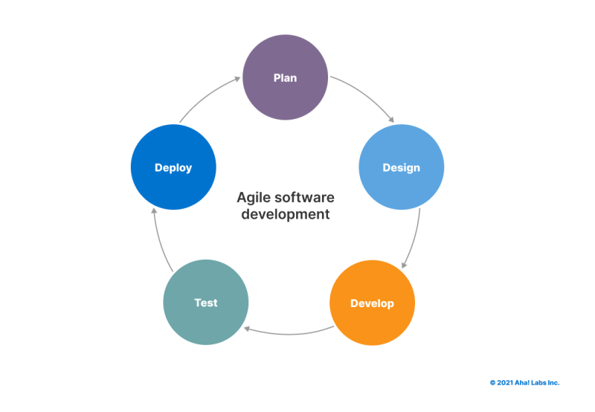

Figure 1:Agile Methodology Diagram

# 3.7 SYSTEM ANALYSIS AND DESIGN

The system analysis and design phase will involve the following steps:

# 3.7.1 Requirements Gathering

Conducting stakeholder interviews, surveys, and observations to identify user needs, system requirements, and functional specifications.

# 3.7.2 System Architecture Design

Defining the overall system architecture, including backend databases, application servers, and frontend interfaces, based on the identified requirements.

# Functional and Non Functional Requirements

When developing a warehouse space management system, it is important to define both functional and non-functional requirements to ensure that the system meets the needs of its users and performs efficiently. Here are the typical requirements:

# Functional Requirements

*User Authentication and Authorization*

Users must be able to register and log in with different user roles with varying permissions.

*Space Management*

Allocate and deallocate storage space for inventory item and visual representation of warehouse layout and space utilization.

*Reporting and Analytics*

Generate reports on inventory levels, space utilization, order status, etc.

*Notifications and Alerts*

Alerts for space availability and optimization suggestions.

*User Interface*

Intuitive and user-friendly interface.

*Search and Filter*

Advanced search and filtering options for inventory and orders.

*Access to Historical Data*

Audit trail for changes made to inventory and space allocations.

**Non-Functional Requirements**

*Performance*

Fast response times for user interactions.

*Scalability*

Ability to handle an increasing number of users and support for expanding warehouse locations.

*Reliability*

Ensure high availability and minimal downtime, data backup and recovery mechanisms.

*Security*

Secure data transmission.

Encryption of sensitive data.

Regular security audits and vulnerability assessments.

*Usability*

Easy to learn and use for all user roles with consistent user experience across different devices and platforms.

*Maintainability*

Modular architecture to ease updates and maintenance and comprehensive documentation for users and developers.

*Compatibility*

Compatibility with various devices (desktops, tablets, smartphones) and support for major operating systems and web browsers.

*Compliance*

Adherence to relevant industry standards and regulations, regular updates to maintain compliance with new laws and guidelines.

*Extensibility*

Allow for future enhancements and addition of new features.

***Design Diagrams***

**Context diagram**

The diagram below is a context diagram that is showing the relationship that exists between the various entities in our system:

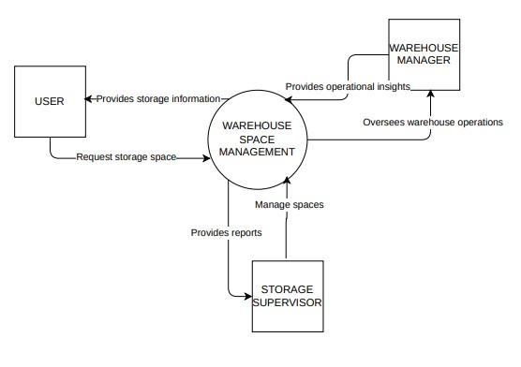

Figure 2: Context Diagram

**Use Case Diagram**

It demonstrates and highlights the context and requirements of the entire system or parts of the system.

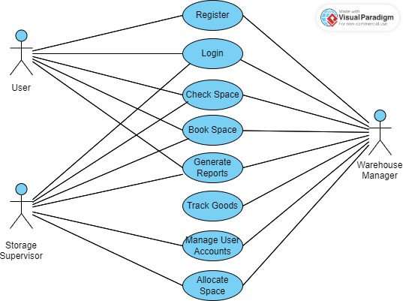

Figure 2; Use case diagram

Figure 3: Usecase

**Data Flow Diagram**

The diagram below is a level one data flow diagram showing the data flow processes in the Warehouse Space Management system.

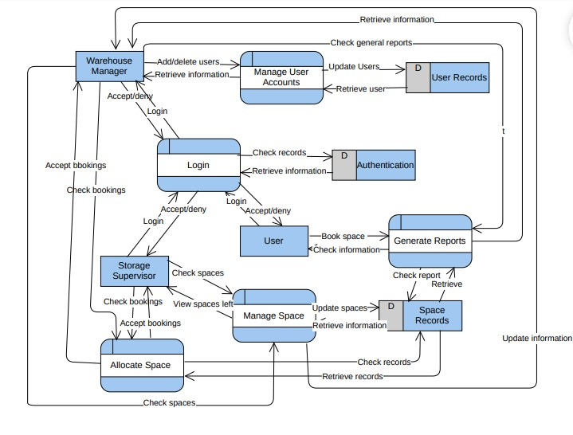

Figure 4: Data Flow Diagram

# Architectural Design

The architectural design of the warehouse space management system includes the following components:

User interface: Web-based application accessible via browsers.

Data access layer.

Database server: Stores and manages data related to warehouse space, inventory, and user activity.

API Layer: Facilitates communication between the client interface and the application server.

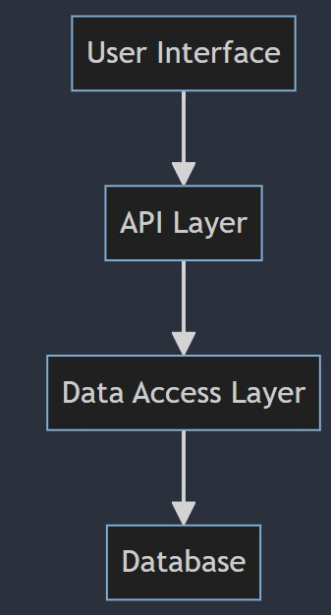

Figure 5: Architectural Design diagram

**Database Design**

The database design for the system includes the following key tables:

Users: Stores user information (user id, name, email, password).

Warehouse: Stores warehouse details (warehouse id, location, capacity).

Items: Stores item data (id, product name, description, weight) and others.

**ERD DIAGRAM**

# 

# 

Figure 6: ERD diagram

# 3.7.3 Prototyping

Developing initial prototypes of the Warehouse Space Management system to validate design concepts and gather feedback from users.

# 3.7.4 Iterative Development

Iteratively refining and enhancing the system based on user feedback and testing results, ensuring that it meets the needs of warehouse operations effectively.

# Conclusion

Warehouse space management is a key area in a warehouse environment as it helps streamline the daily activities of the warehouse. Different warehouses find it difficult to manage their spaces which in turn leads to poor space utilization and inaccurate analytics. Various stakeholders in the warehouse world have come up with strategies on how to utilize space, for example Amazon has deployed KIVA robots to their organization to streamline warehouse storage operations.

In my system, I intend to create a warehouse space management system that will ensure that the storage booking procedure is smooth at can be done from the comfort of the user. The system will include a user friendly interface, a responsive backend and database and an Admin panel. The admin panel will help the necessary employees to update the spaces in the warehouse and also assist users who find it difficult to login into the system. The user interface will help a user to easily access all storage spaces and book them. The backend will be the key link between the database and the frontend to ensure a smooth user experience and database access.

Several studies will be conducted to identify what customers require in the system and also know what has been the major issue in the existing systems. Due to limited time and resources, my system will mostly delve on a streamlined booking system. Agile methodology will be used and a systematic software development life cycle (SDLC) will be deployed considering all the functional and non-functional requirements.

Upon completion, the system will be very smooth and user friendly and all ethical factors, data privacy and copyright rules will be adhered to. This will ensure that the system does not infringe all set rules and regulations.

# REFERENCES

1. Richards, G. (2017). Warehouse Management: A Complete Guide to Improving Efficiency and Minimizing Costs in the Modern Warehouse. Kogan Page Publishers.
2. Frazelle, E. (2002). World-Class Warehousing and Material Handling. McGraw-Hill.
3. Gu, J., Goetschalckx, M., & McGinnis, L. F. (2010). Research on warehouse operation: A comprehensive review. European Journal of Operational Research, 203(3), 539-549.
4. Baker, P., & Canessa, M. (2009). Warehouse design: A structured approach. European Journal of Operational Research, 193(2), 425-436.
5. Tompkins, J. A., White, J. A., Bozer, Y. A., & Tanchoco, J. M. A. (2010). Facilities Planning. John Wiley & Sons.
6. Bartholdi, J. J., & Hackman, S. T. (2019). Warehouse & distribution science. CreateSpace Independent Publishing Platform.
7. Rouwenhorst, B., Reuter, B., Stockrahm, V., van Houtum, G. J., Mantel, R. J., & Zijm, W. H. (2000). Warehouse design and control: Framework and literature review ©

# APPENDICES

**Appendix 1: Gantt chart**

|  |  |  |  |  |  |  |  |  |  |  |
| --- | --- | --- | --- | --- | --- | --- | --- | --- | --- | --- |
| No | Activity | May 31st | | 1st June – 17th June | | 18th June – 28th June | |  | 29th June – 31st July | |
| 1. | Project proposal approval |  |  |  |  |  |  |  |  |  |
| 2. | Chapter 1 presentation: Introduction |  |  |  |  |  |  |  |  |  |
| 3. | Chapter 2  Presentation: Literature Review |  |  |  |  |  |  |  |  |  |
| 4. | Chapter 3 presentation: Research Design and Methodology |  |  |  |  |  |  |  |  |  |
| 5. | Documentation &  Presentation |  |  |  |  |  |  |  |  |  |

**Appendix 2: Budget**

|  |  |
| --- | --- |
| Item | Cost |
| Internet | Ksh.1000 |
| Printing | Ksh.300 |
| Total | Ksh.1300 |